Relational DBMS
# Source: AI Source: Provided by: [Data Path: Persons Table -> ID Column: 1, Name_En Column: Motasem Essam] -> From: [ChatGPT] on [6/10/2026]
A Relational Database Management System (RDBMS) is software that allows you to create, manage, and interact with relational databases. It provides tools to store data in tables and manage relationships between those tables using SQL (Structured Query Language).

📦 In Simple Terms:
# Source: AI Source: Provided by: [Data Path: Persons Table -> ID Column: 1, Name_En Column: Motasem Essam] -> From: [ChatGPT] on [6/10/2026]
An RDBMS is like a smart digital filing cabinet where:
- Tables store related information (like spreadsheets).
- You can easily search, update, insert, and delete data using SQL.
- It ensures data accuracy and consistency through rules and constraints.

🧱 Key Features of an RDBMS
# Source: AI Source: Provided by: [Data Path: Persons Table -> ID Column: 1, Name_En Column: Motasem Essam] -> From: [ChatGPT] on [6/10/2026]
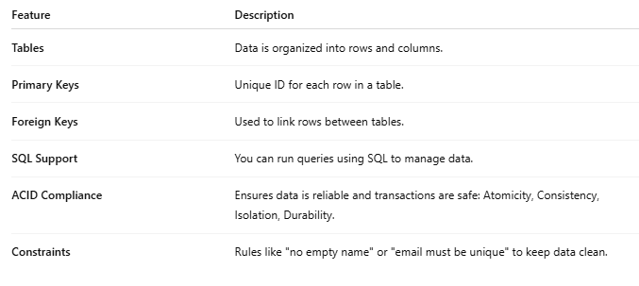
Feature | Description
Tables | Data is organized into rows and columns.
Primary Keys | Unique ID for each row in a table.
Foreign Keys | Used to link rows between tables.
SQL Support | You can run queries using SQL to manage data.
ACID Compliance | Ensures data is reliable and transactions are safe: Atomicity, Consistency, Isolation, Durability.
Constraints | Rules like "no empty name" or "email must be unique" to keep data clean.

🗃️ Example RDBMS
# Source: AI Source: Provided by: [Data Path: Persons Table -> ID Column: 1, Name_En Column: Motasem Essam] -> From: [ChatGPT] on [6/10/2026]
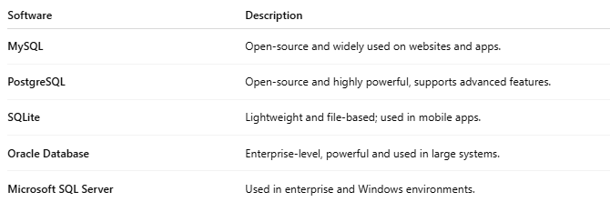
Software | Description
MySQL | Open-source and widely used on websites and apps.
PostgreSQL | Open-source and highly powerful, supports advanced features.
SQLite | Lightweight and file-based; used in mobile apps.
Oracle Database | Enterprise-level, powerful and used in large systems.
Microsoft SQL Server | Used in enterprise and Windows environments.

📝 Example: SQL Query
# Source: AI Source: Provided by: [Data Path: Persons Table -> ID Column: 1, Name_En Column: Motasem Essam] -> From: [ChatGPT] on [6/10/2026]
Let’s say you have a Users table and want to get all users with the name "Alice":
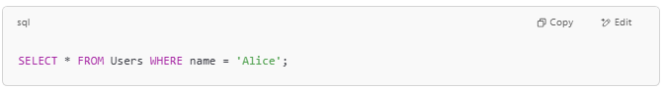
SELECT * FROM Users WHERE name = 'Alice';

✅ Why Use an RDBMS?
# Source: AI Source: Provided by: [Data Path: Persons Table -> ID Column: 1, Name_En Column: Motasem Essam] -> From: [ChatGPT] on [6/10/2026]
- Manages large amounts of structured data
- Ensures data integrity and security
- Supports multi-user access and permissions
- Easy to search, sort, and relate data

